**JENKINS BY ASHOK**

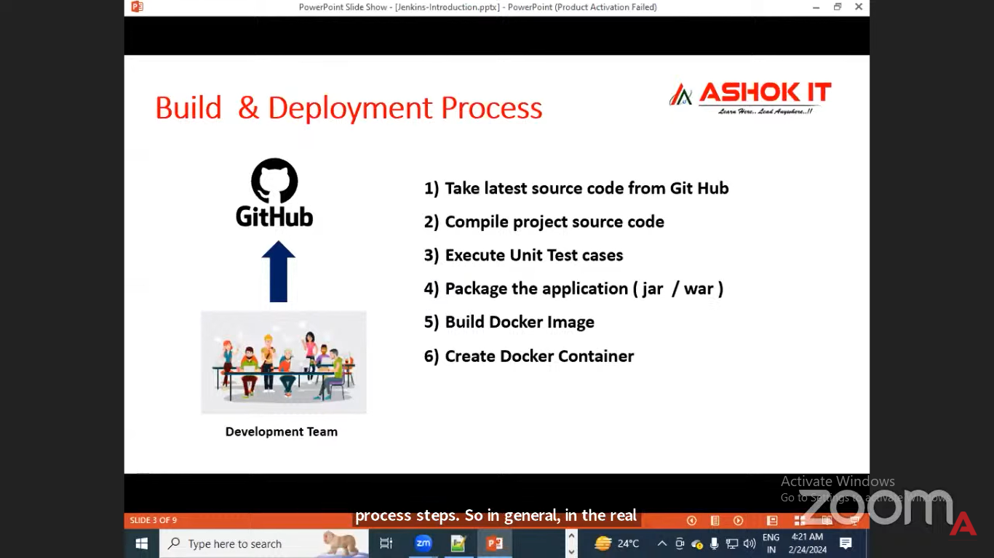

Challenge in manual process

Continuously modiefied code pushed into repository

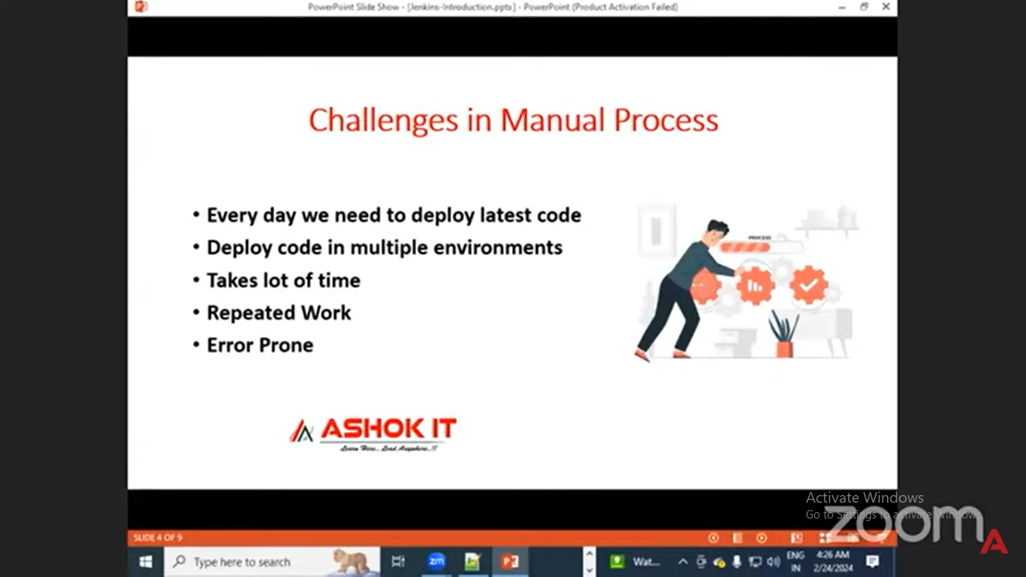

Whatever things we do manually we do weith Jenkins software

Jenkins automate project build and deployment automate the entire process

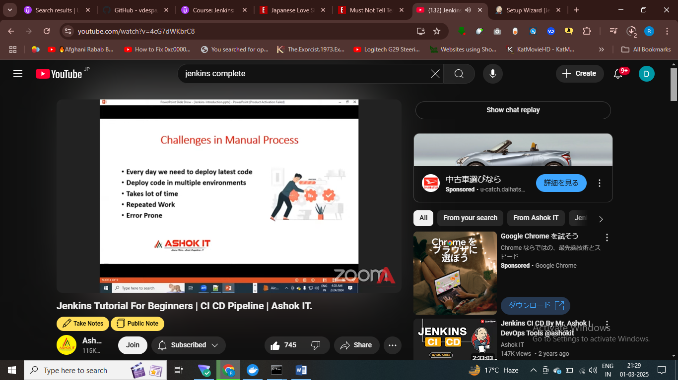

Jenkins with docker to build and deploy the appn

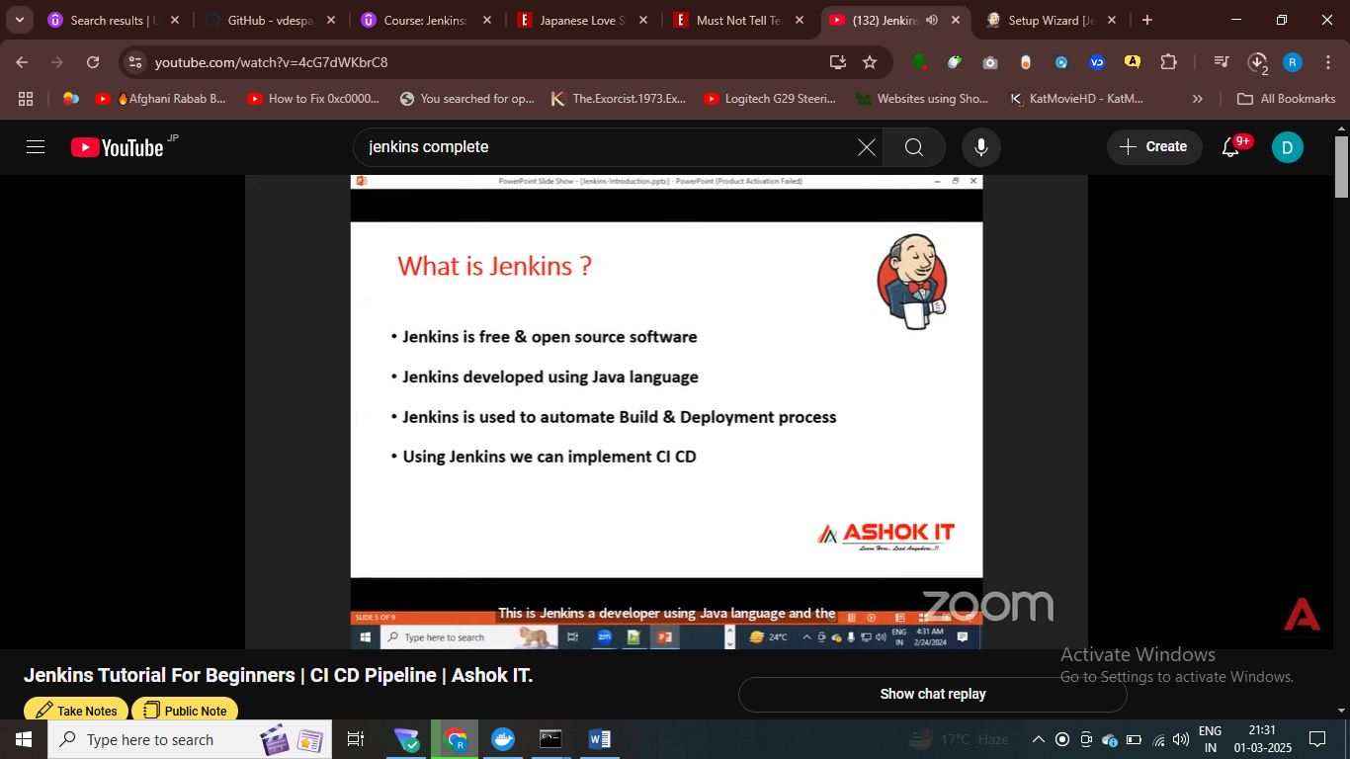

When developer modified the code – we can build and deploy the appn

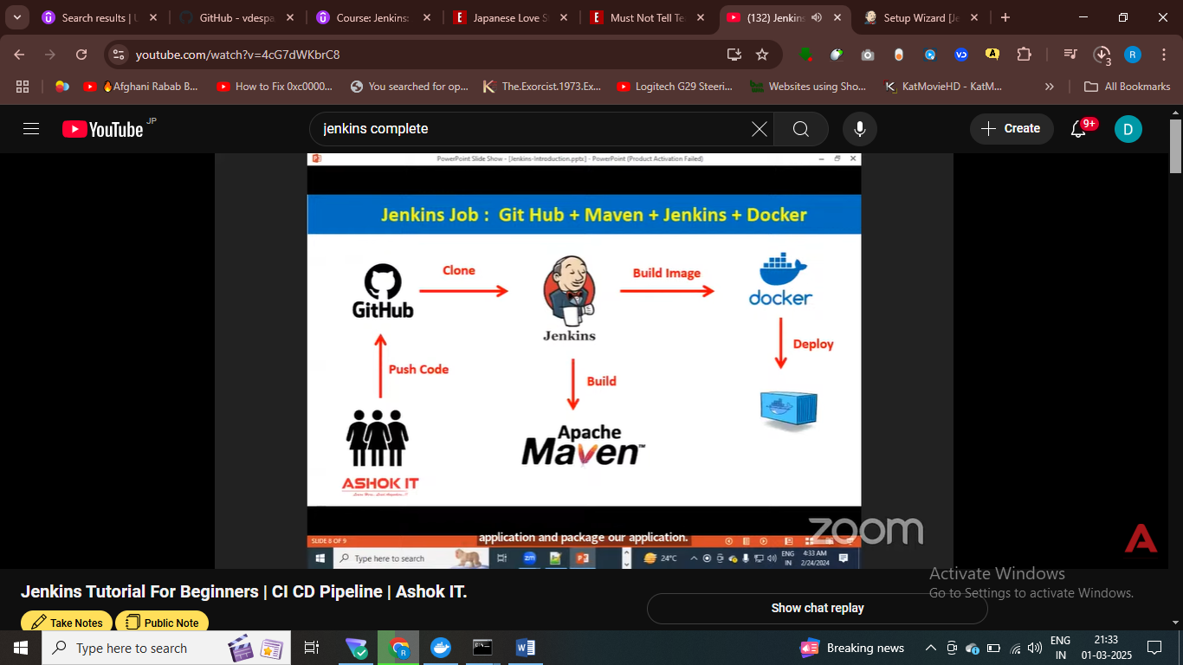

# using maven we build the appn , after theat we simply deploy the appn inside docker container , maven packge the appn

* Maven packge the code and build the code –compile the cdoe

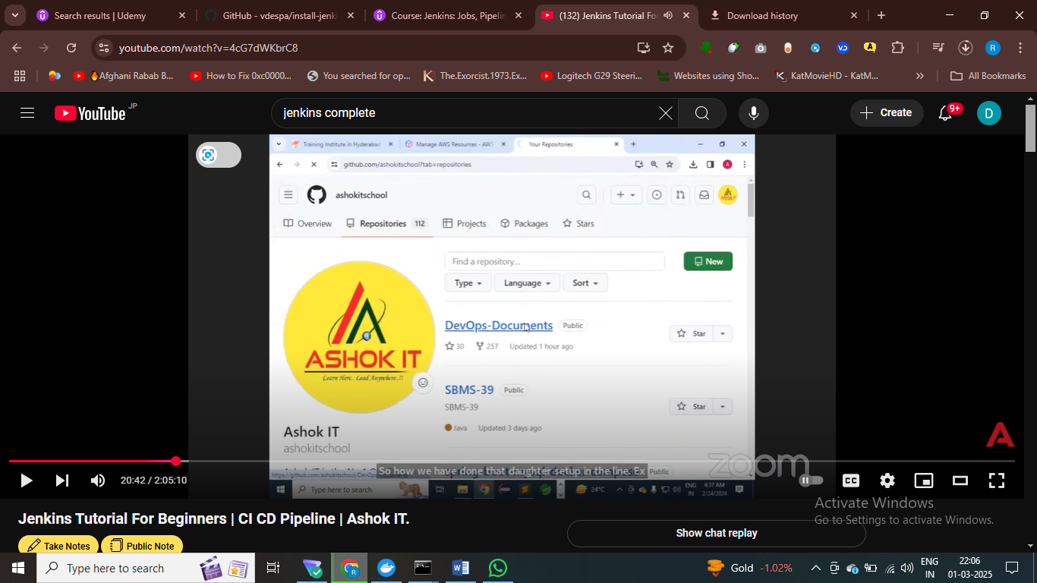

# after building docker images – we will use kubernetes for creating containers

Jenkins-docker-intergrations

Jnekins is cicd server used to automate entire things from build to deploye

Automate build and deploy process using Jenkins

Job in Jenkins nothing but a way to create a pipeline to automate everything from build to deploy , we will automate entire things using these jobs

In a freestyle we have gui available to create a job ,

In a pipeline job , script will be available to create a job

In Jenkins, go to create a jon

Setup

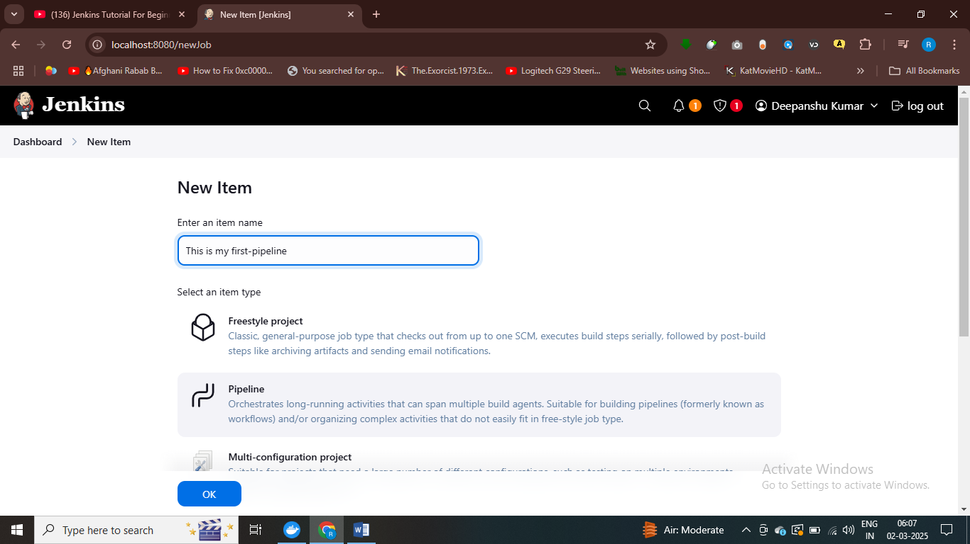

Groovy langague to write Jenkins pipeline in scripted approach

So in scripted pipeline we write pipeline like English statement , using groovy script

Pipeline is series of steps – sending from water to upper part to

Set of steps in Jenkins job1 called pipeline

Go to save then build now

* Project pipeline complex process – so use pipeline job
* Freestyle for basic build and deployment

We have two pipeline – declarative pipeline and scripted pipeline

* Declarative pipeline when we don’t know groovy

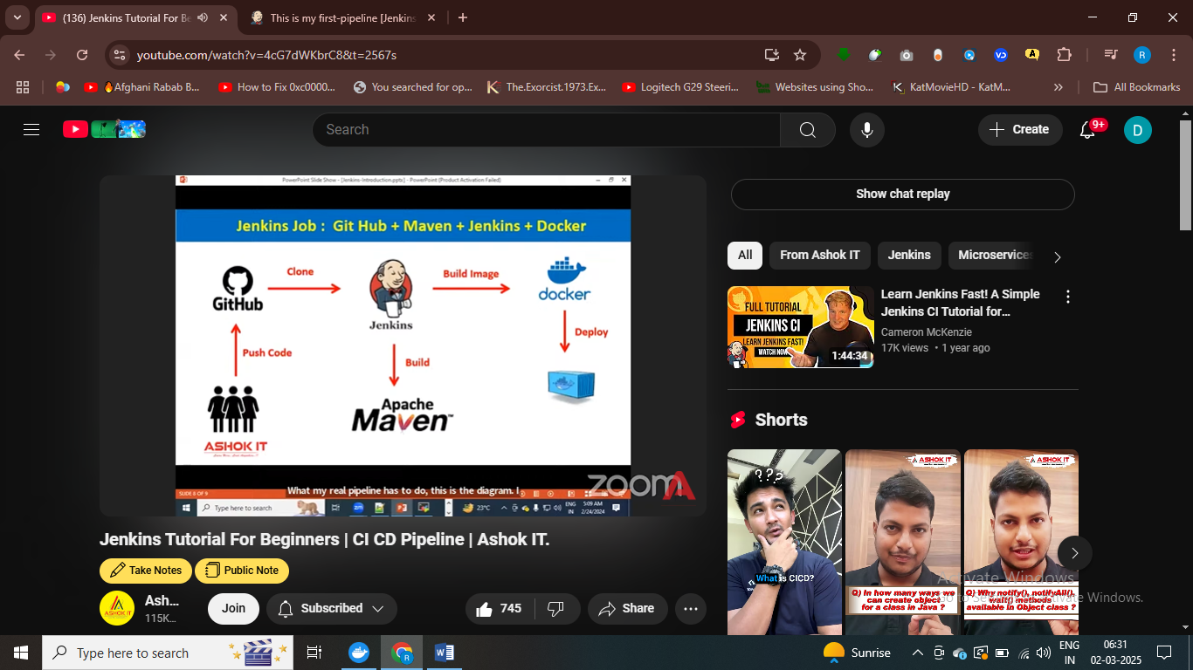

Ci cd pipeline for this steps

Our pipeline start from keyword pipeline which represent it’s declarative pipeline , and if start from node then it is scripted pipeline

Pipeline{ node{}

}

Then agent any{} – you can use any mchine , multiple machine available and in which machine yu want to run

Jenkins backup – how to take backup of our Jenkins job – if our machine crashes then how to backup our Jenkins jobs – we use tin-backup plugin – to

Whatever machine available jenknins run our job on that machine

Then stages we write

Pipeline {

Agent any

Stages{

}}

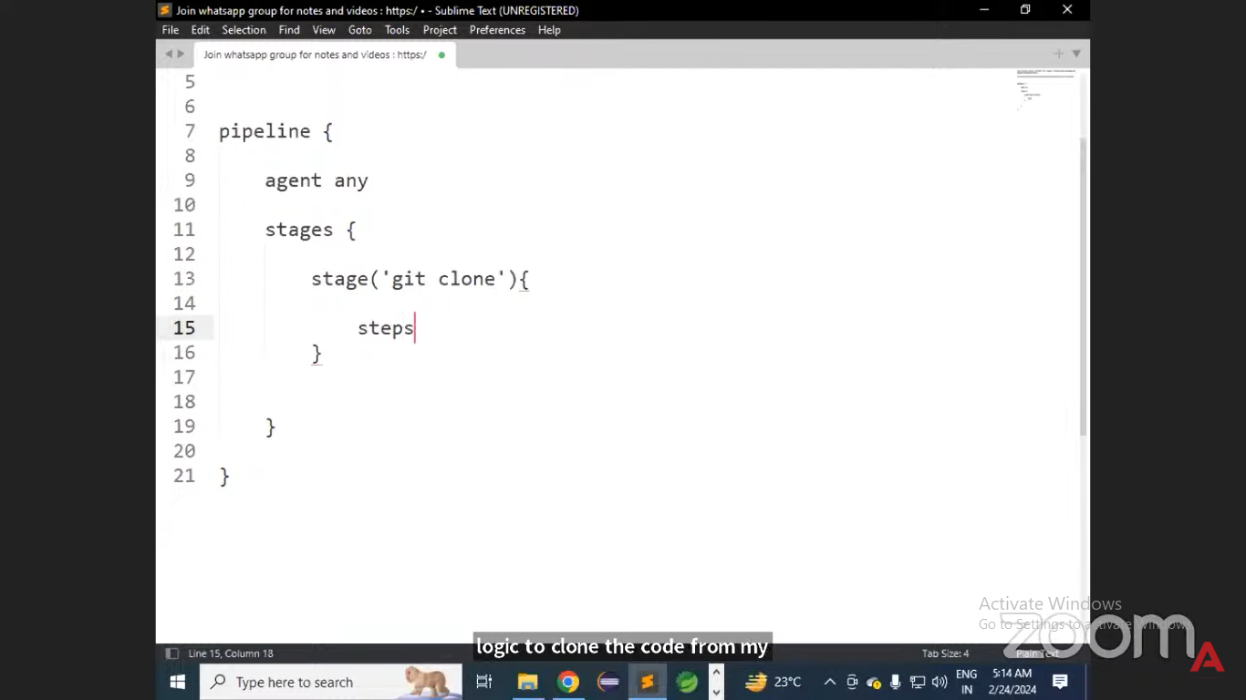

# first stages we write logic for clone the reposity

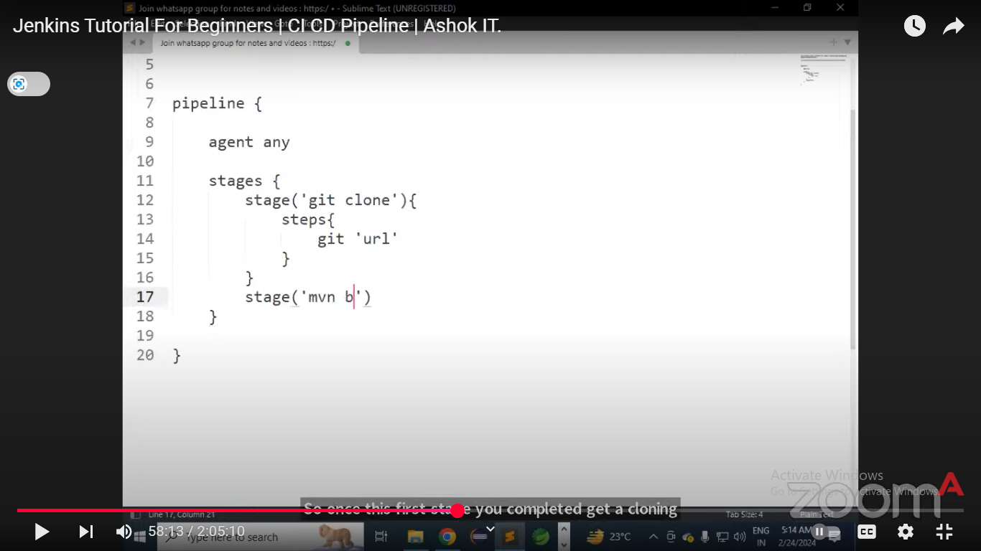

# git clone – first stage is clone the repo – we specify git url

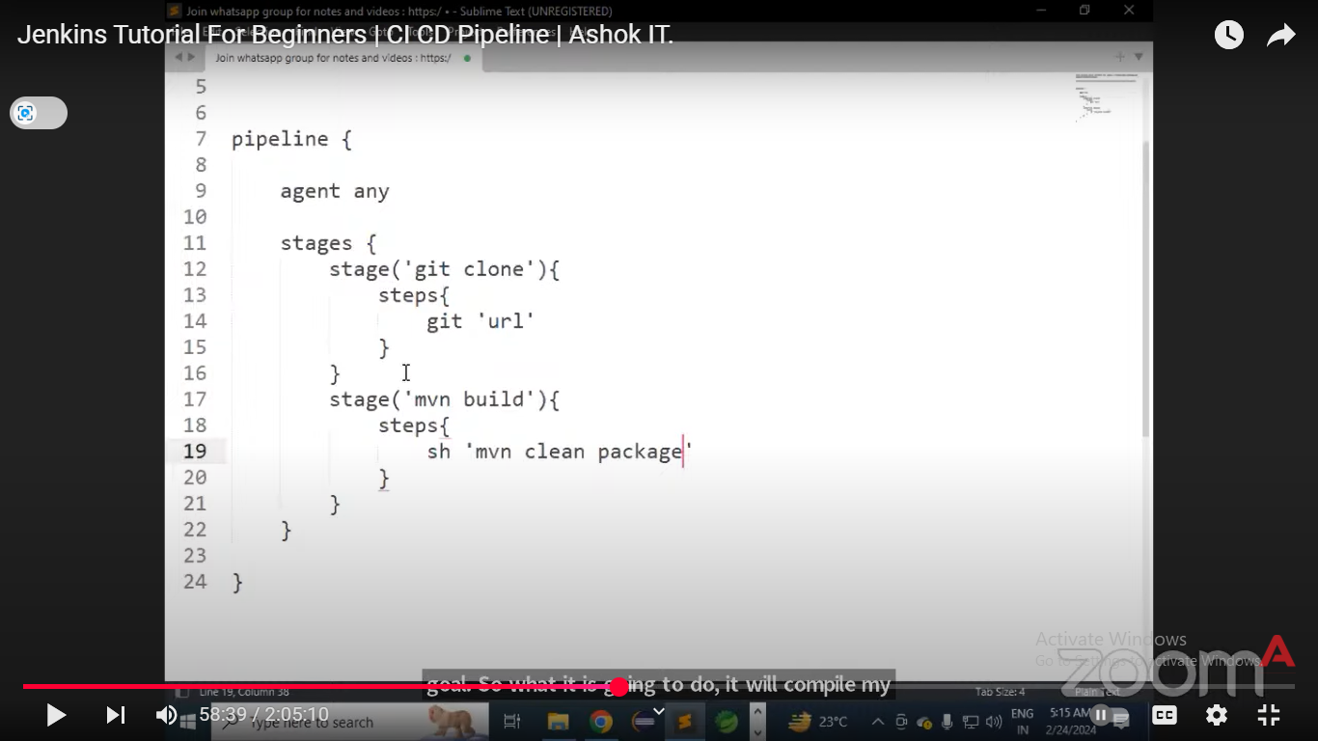

Stage – mvn-build – this will package our appn as var or jar files

After packaging the appn we will – build the docker iamge

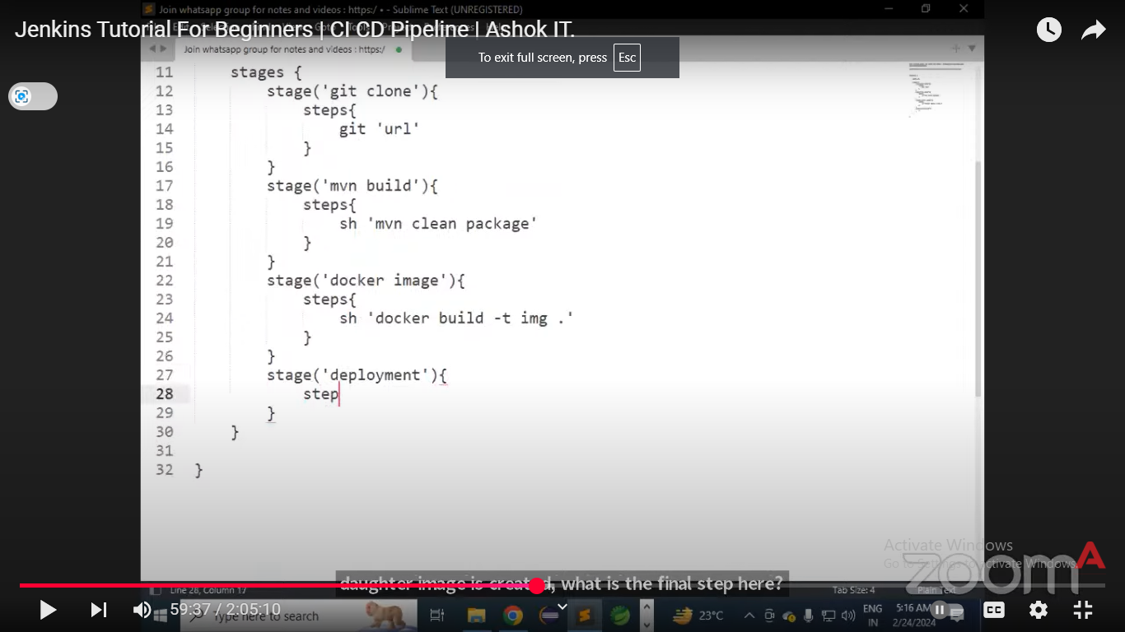

Next staege is building the docker image and after that next stage is deployment

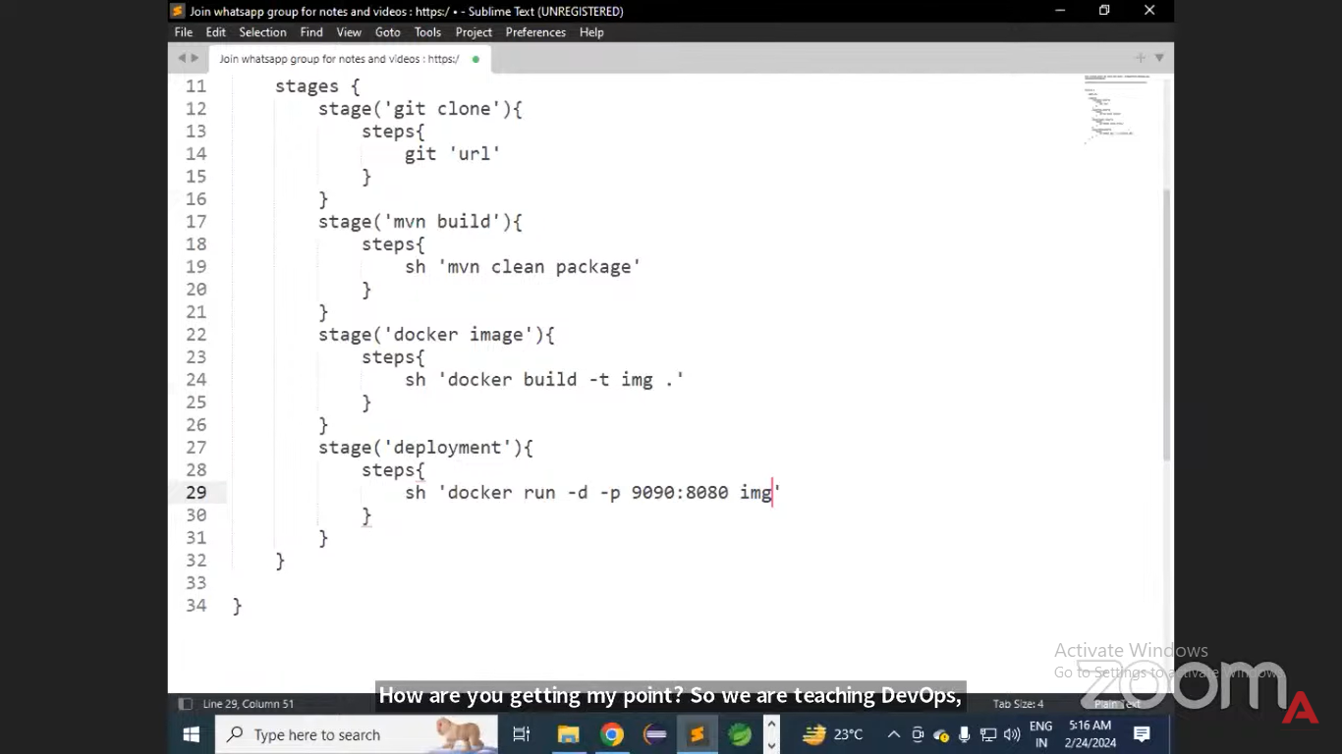

For deployment – next stage build docker container using img and exposing port

Set of steps or stages known as ci cd pipeline

Diffrestnt stage we have in cicd pipeline is –

Clone the repo

Using maven pacgke the appn

Building docker iamge

Then docker container using image

* Deploy docker image in kuberntes cluster
* This is called cicd pieplen

1. Start with pipeline keyword means it is declarative pipeline
2. Agent any we have multiple mahcine which is master slave architecture ,we are going to configure master slave architecture
3. Agent vm-1 , I want to execute the job in vm1 , agent vm-2 – I want to execute the job in machine2 , so depend on machine availbel we can run
4. Then stages – it refer to steps that we want to perform
5. Pipeline is comb of multiple stage and each stage perform some specific openration
6. Git clone one stage , maven build second stage , image creatinon one stage , container creation one stage
7. <https://github.com/ashokitschool/maven-web-app.git> - deploying this appn using docker
8. First we create docker image and then we create container

GO TO Pipeline syntax to learn about syntax of clone the repo

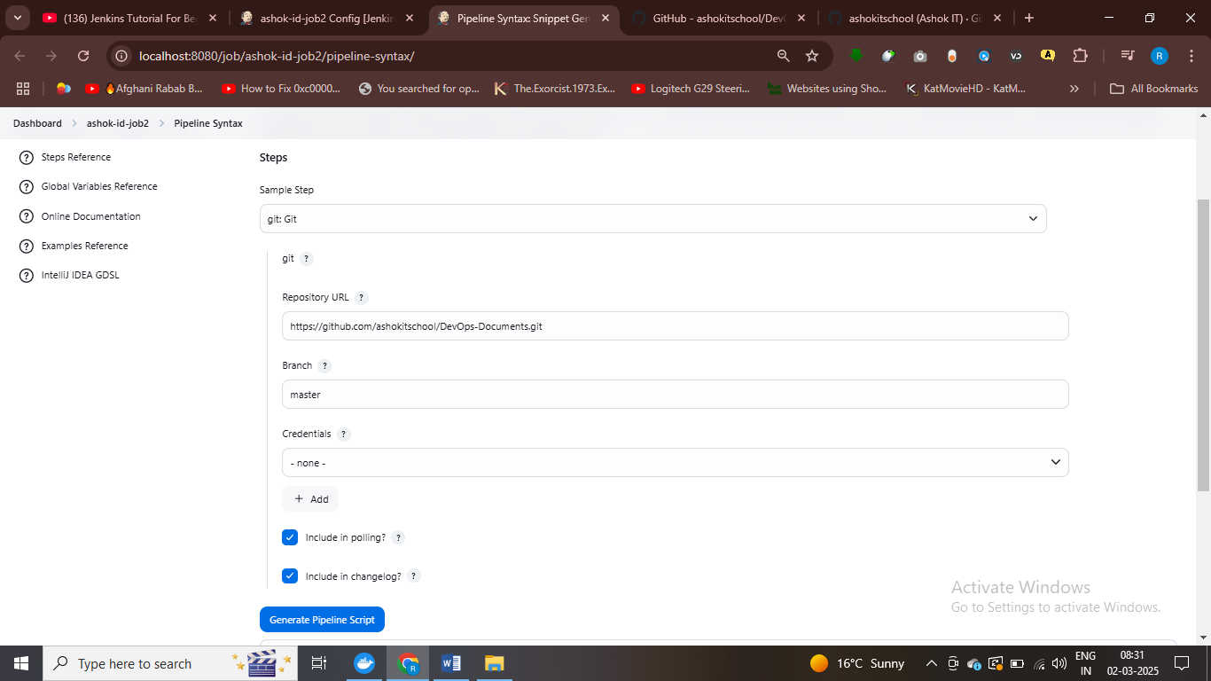

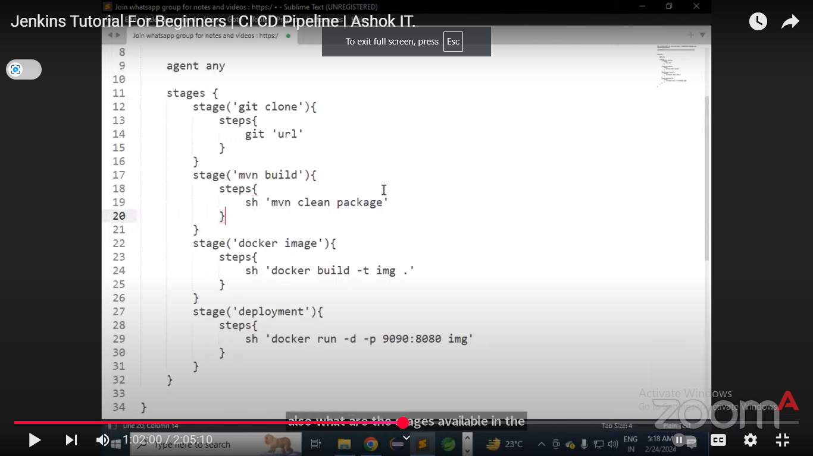

pipeline {

agent any

stages {

stage('Git Clone') {

steps {

git branch: 'main',

url: 'https://github.com/ashokitschool/DevOps-Documents.git'

}

}

}

}

# stage 1 git clone the repo – manually by specifying branch

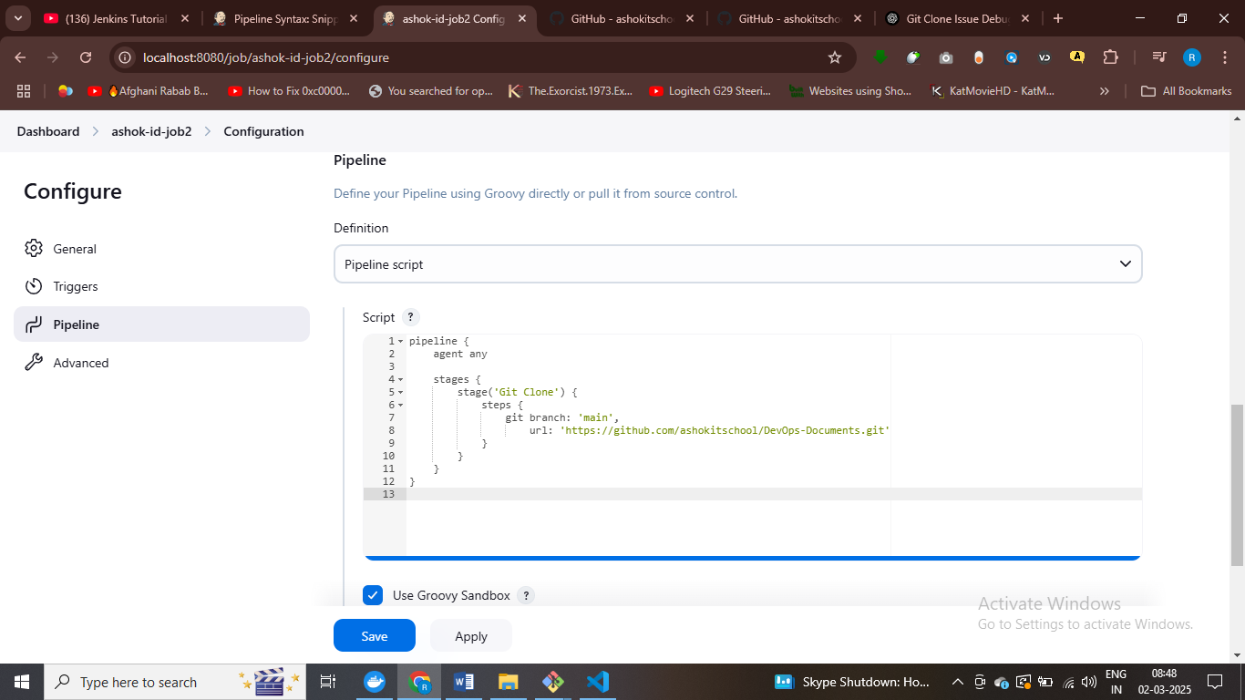

# second stage is maven build

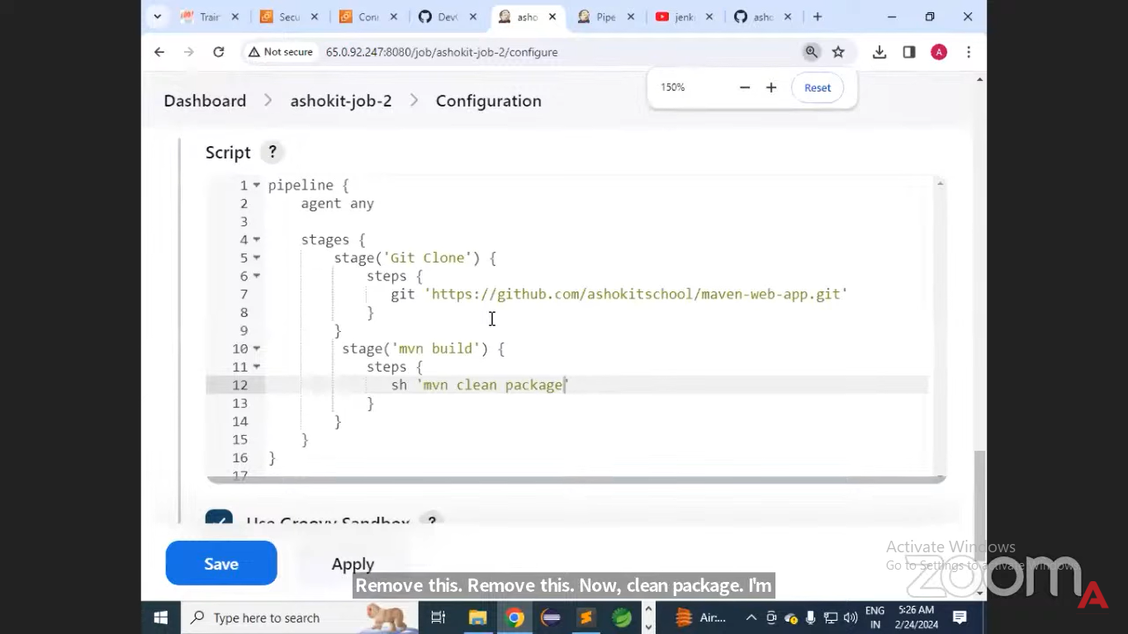

#mvn compile the project ,test it and package the project as var file or jar file

pipeline {

agent any

tools {

maven 'Maven3' // Ensure Maven is installed in Jenkins

}

stages {

stage('Clone Repository') {

steps {

git branch: 'master', url: 'https://github.com/ashokitschool/maven-web-app.git'

}

}

stage('Build with Maven') {

steps {

sh 'mvn clean package' // Runs the Maven build process

}

}

}

}

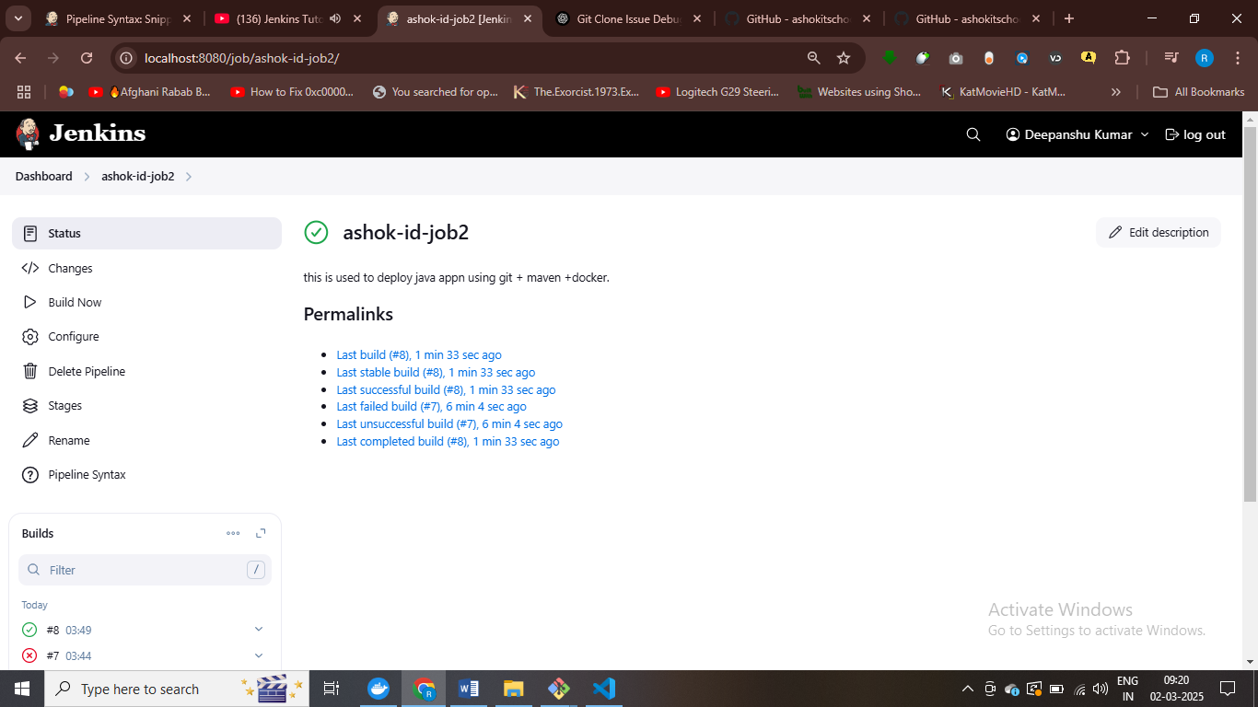

#succesfully package appn using maven tool

I have installed maven as tool , so I need to specify

Tools{maven}

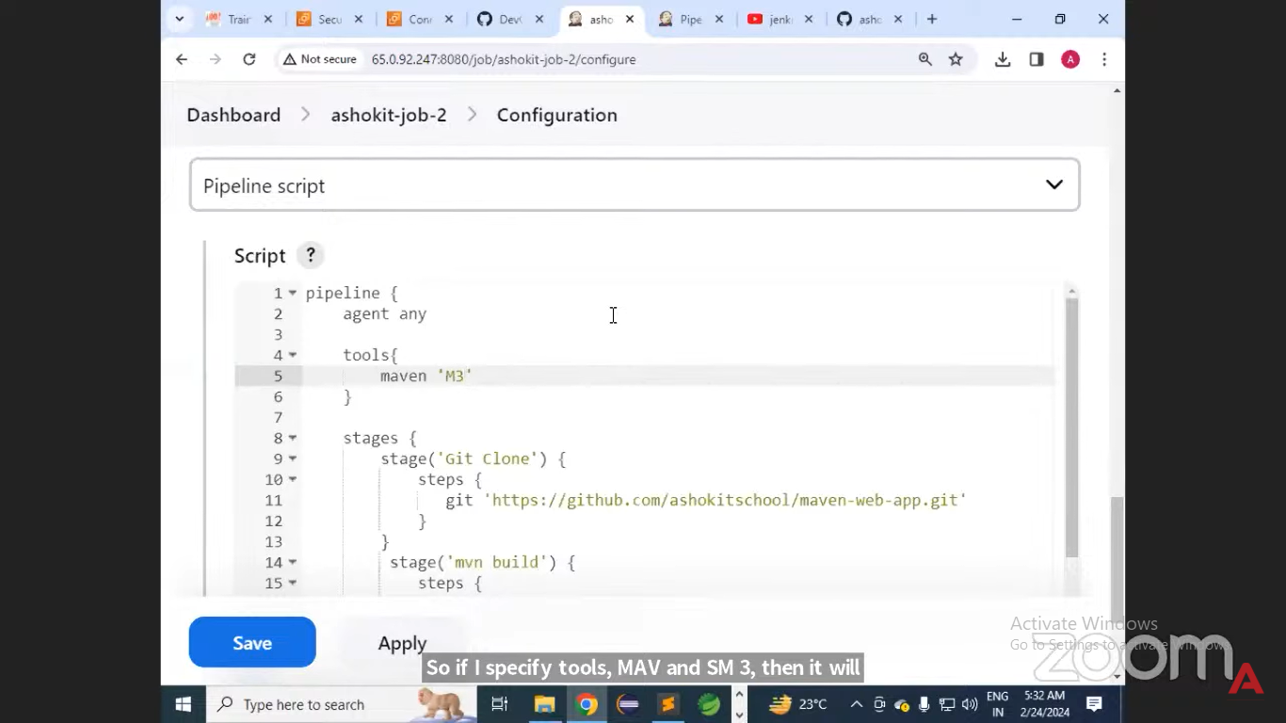

# maven Maven3

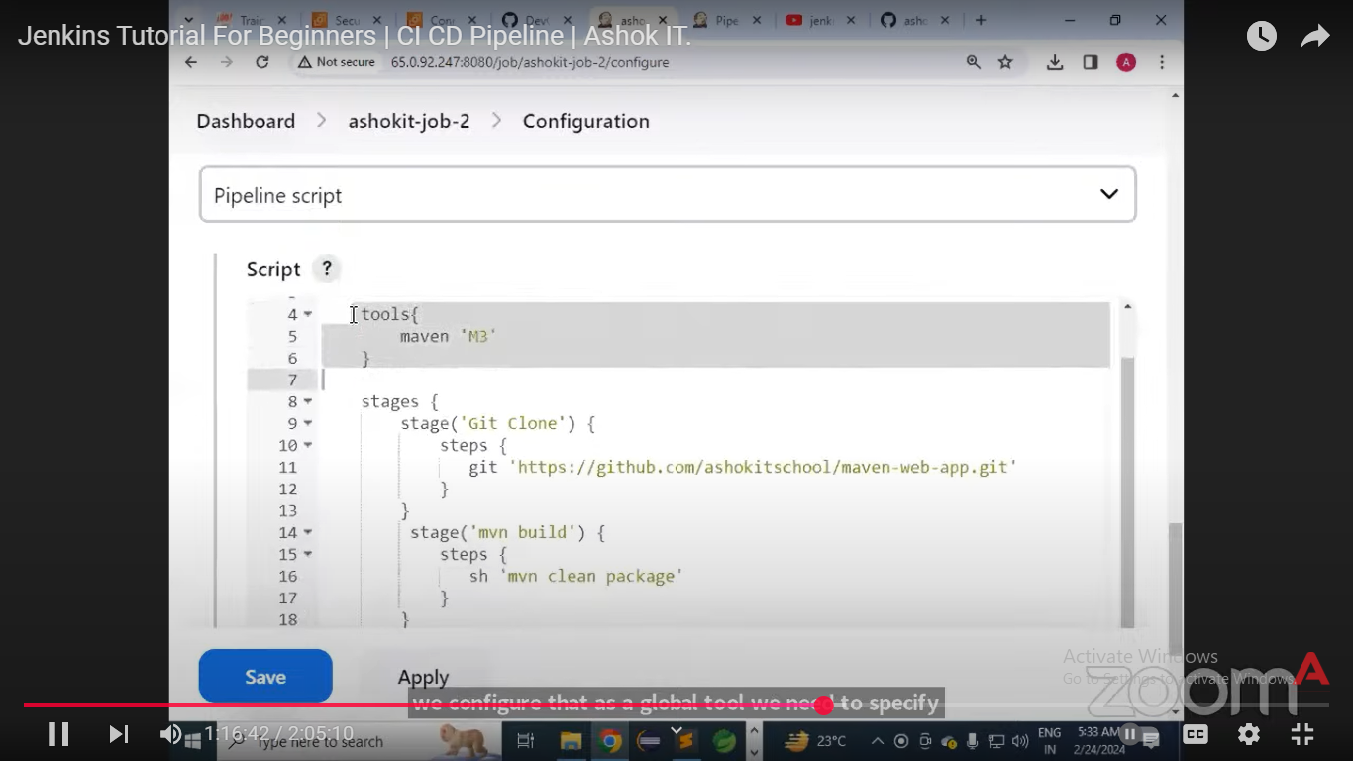

# we need to specify tool name here and tehn we can use maven

# maven can be used as global tool to package our appn

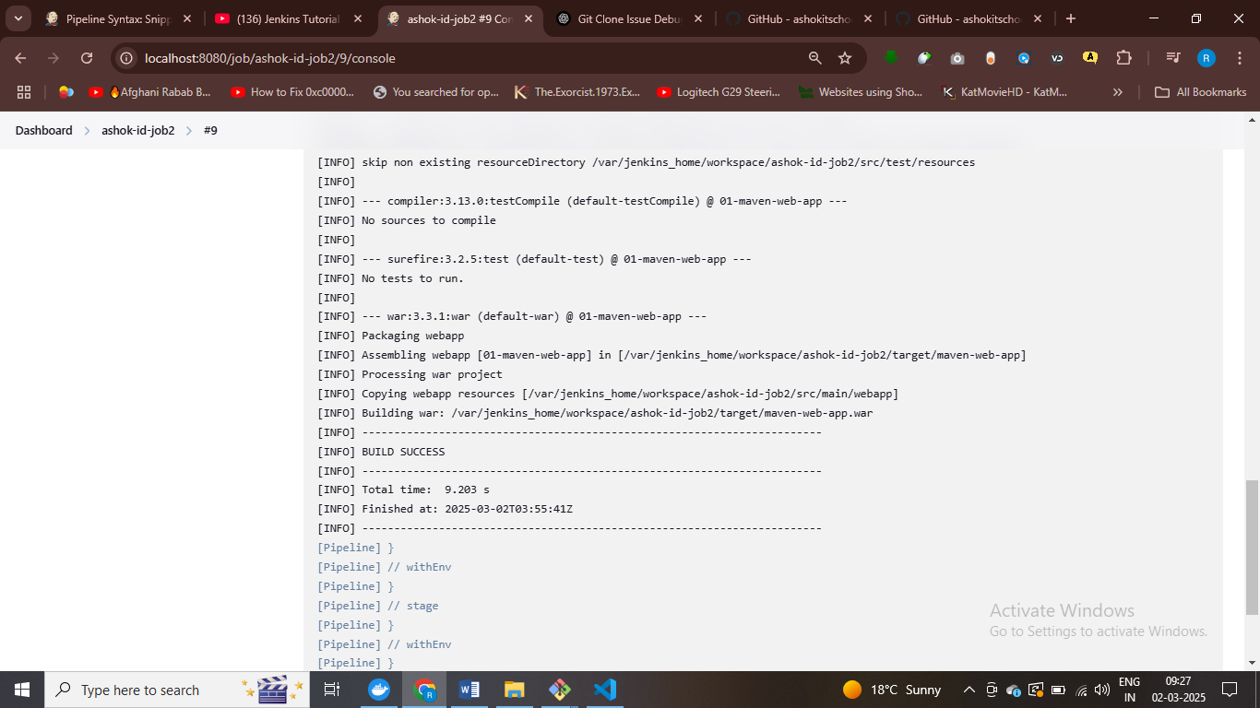

The process is packages as war file

Now we build docker iamges

Using docker file build docker iamge

We can give any name to stage

pipeline {

agent any

tools {

maven 'Maven3' // Ensure Maven is installed in Jenkins

}

stages {

stage('Clone Repository') {

steps {

git branch: 'master', url: 'https://github.com/ashokitschool/maven-web-app.git'

}

}

stage('Build with Maven') {

steps {

sh 'mvn clean package' // Runs the Maven build process

}

}

stage('Docker Image'){

steps{

sh 'docker build -t ashokit .'

}

}

}

}

# name of image is ashokit , this is java appn using tomcat web server have port 8080 and Jenkins port8080

Jenkins also using port 8080 so we need to map tomcat port with some other port

Mapping tomcat to 9090 as Jenkins using 8080, 9090 :8080 – first is host port and next is container port

If anybody hit on port 9090 then it will direct to 8080 port

Creating a docker container for deployment using ashokit image and exposing port of tomcat web server

pipeline {

agent any

tools {

maven 'Maven3' // Ensure Maven is installed in Jenkins

}

stages {

stage('Clone Repository') {

steps {

git branch: 'master', url: 'https://github.com/ashokitschool/maven-web-app.git'

}

}

stage('Build with Maven') {

steps {

sh 'mvn clean package' // Runs the Maven build process

}

}

stage('Docker Image'){

steps{

sh 'docker build -t ashokit .'

}

}

stage('Docker Container Deployment'){

steps{

sh 'docker run -d -p 9090:8080 --name deepanshu-c1 ashokit'

}

}

}

}

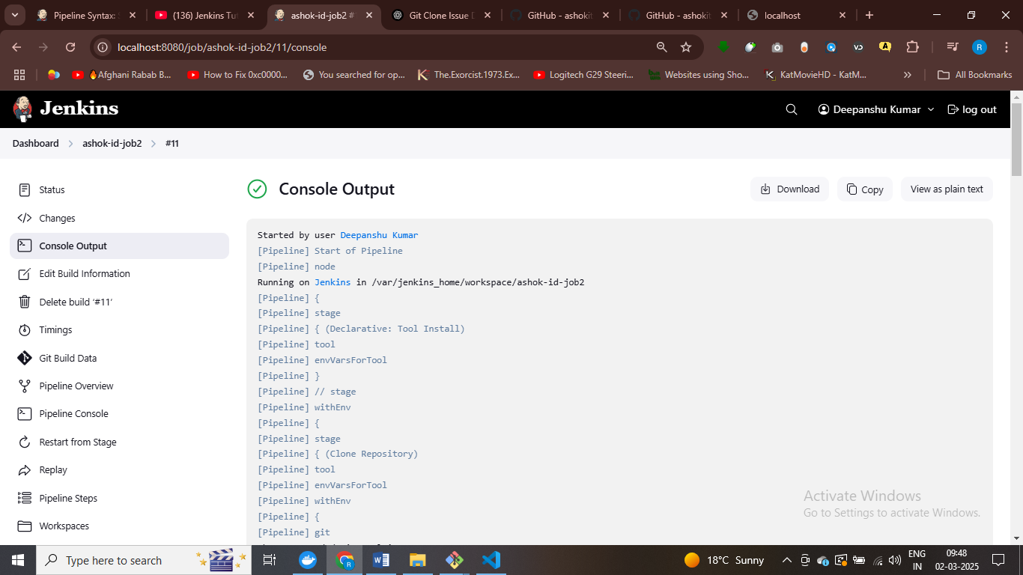

pipeline {

agent any

tools {

maven 'Maven3' // Ensure Maven is installed in Jenkins

}

stages {

stage('Clone Repository') {

steps {

git branch: 'master', url: 'https://github.com/ashokitschool/maven-web-app.git'

}

}

stage('Build with Maven') {

steps {

sh 'mvn clean package' // Runs the Maven build process

}

}

stage('Docker Image'){

steps{

sh 'docker build -t ashokit .'

}

}

stage('Docker Container Deployment'){

steps{

sh 'docker stop deepanshu-c1'

sh 'docker rm deepanshu-c1'

sh 'docker run -d -p 9090:8080 --name deepanshu-c1 ashokit'

}

}

}

}

# stop if any container exist and then remove and then start a fresh containers

ON – Demand build process when we are pressing build botton manually , whenever you want you run the job means on –demand

If job is modified or code is modify Jenkins job will be triggred

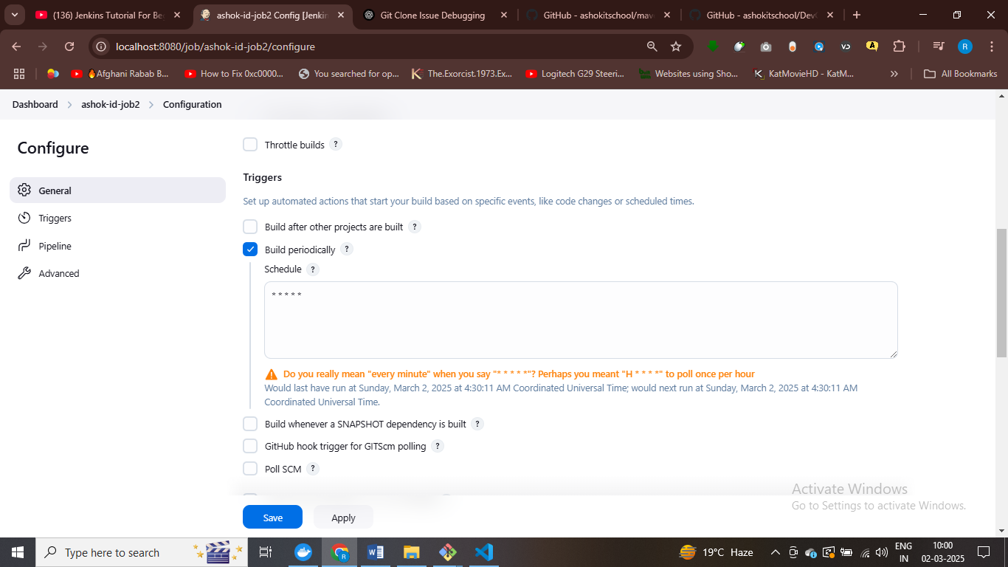

For every one minute the job will be executes,

It 5 star represtn cron expression

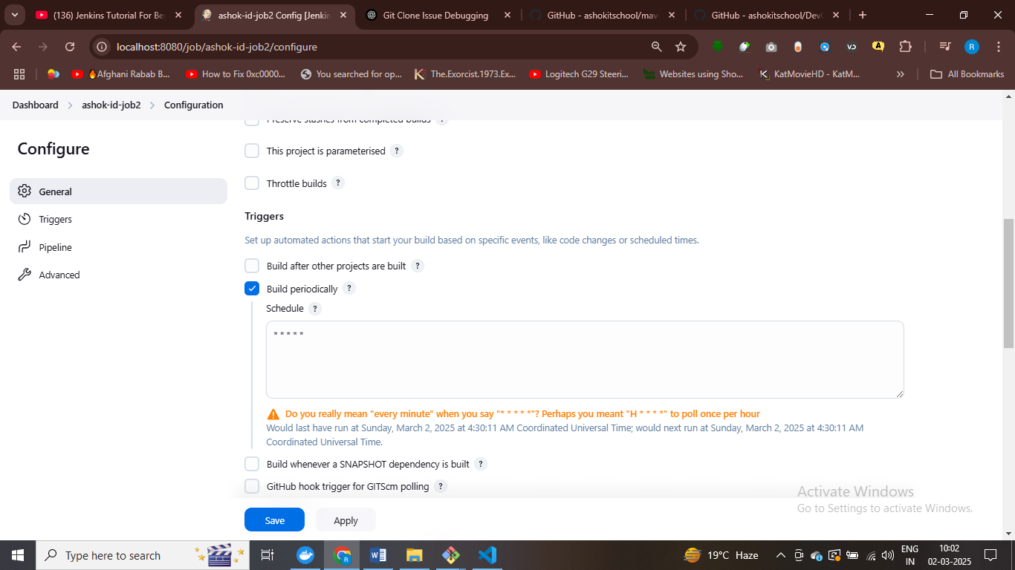

Automatically build is scheduled

Poll scm communicate with github in evry one minute – if anyone modified the code then job will be trigger otherwise not

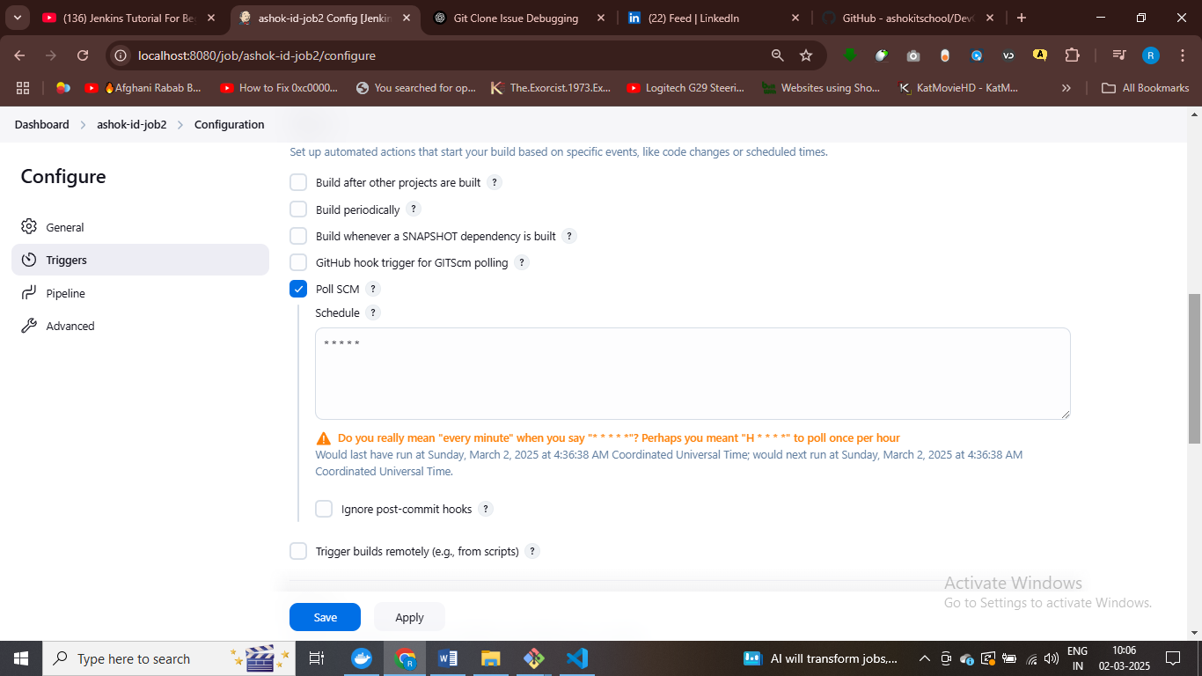

If code is modified then automatically build is trigger , if not then build is not triggred

Jenkins is ci cd software

Earlier people do this process manually now we automating build and deploy process

Build perdiocally – based on 1 hour trigger job

Execute the job with code change

Poll scm wieth 5 star

If any change in github then it will trigger build –it weill check github at evey one minute – means 5 stat

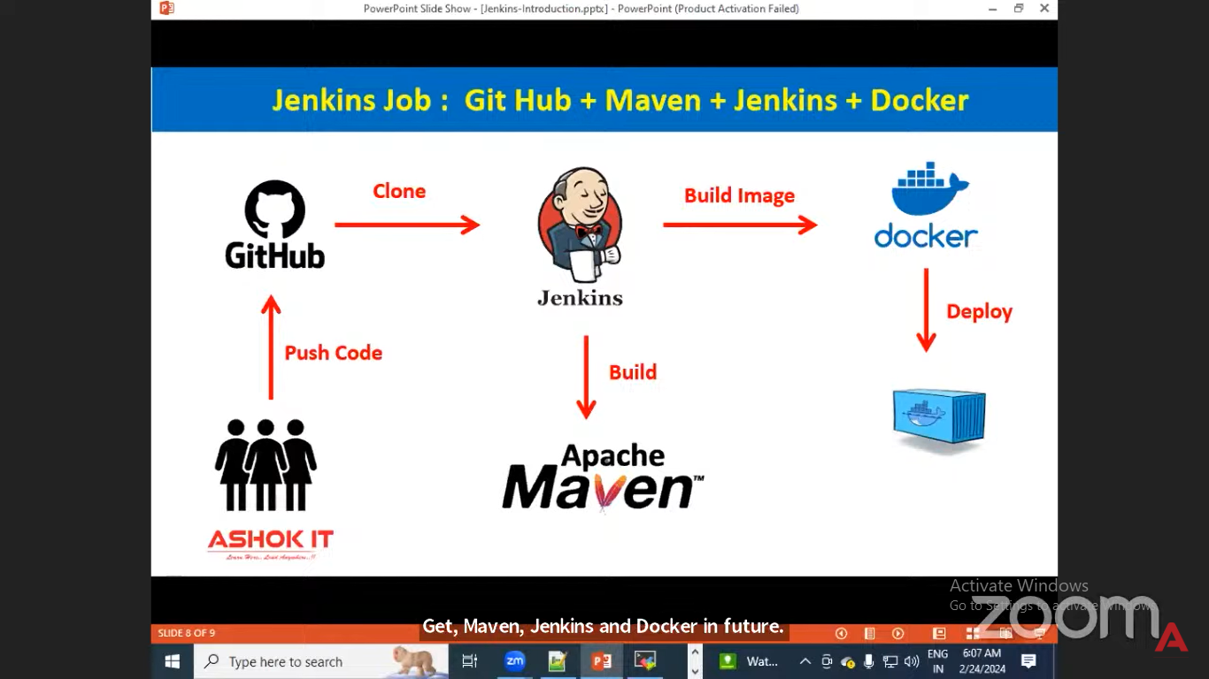

In future kuberntes will come for deployments

Jenkins backup – Jenkins cluster – manage by devops admistrator

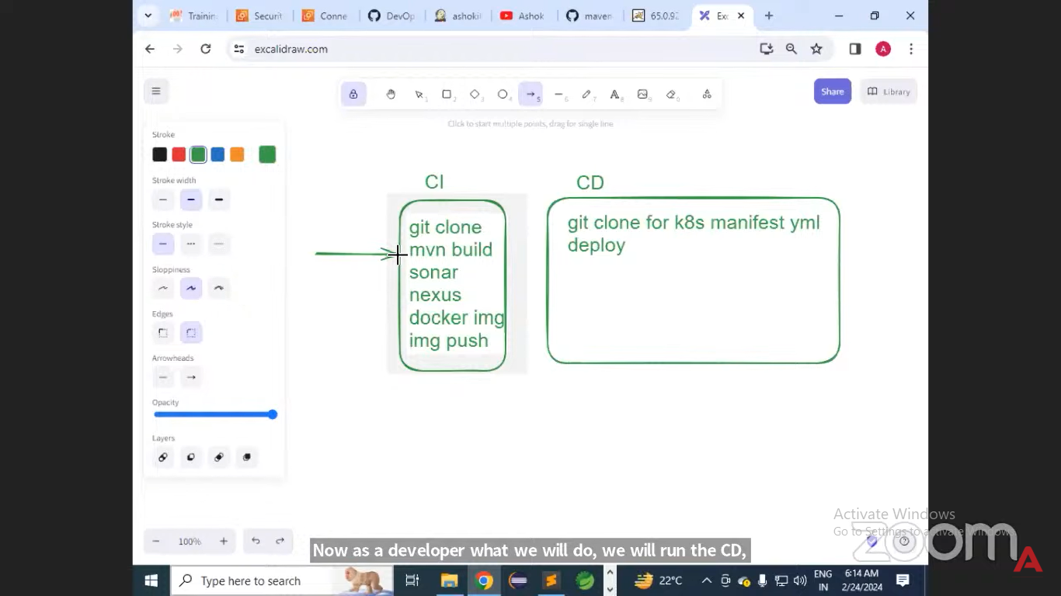

HOW DO YOU trigger one job from another job ?

From Jenkins

We need to add one more stage in Jenkins

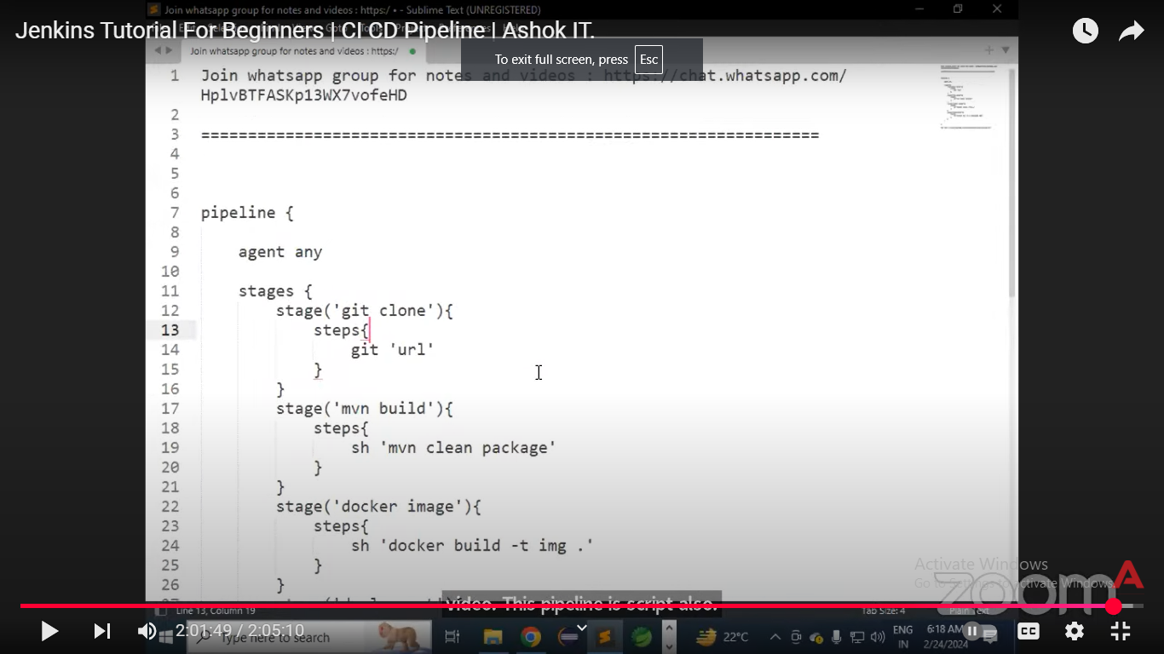

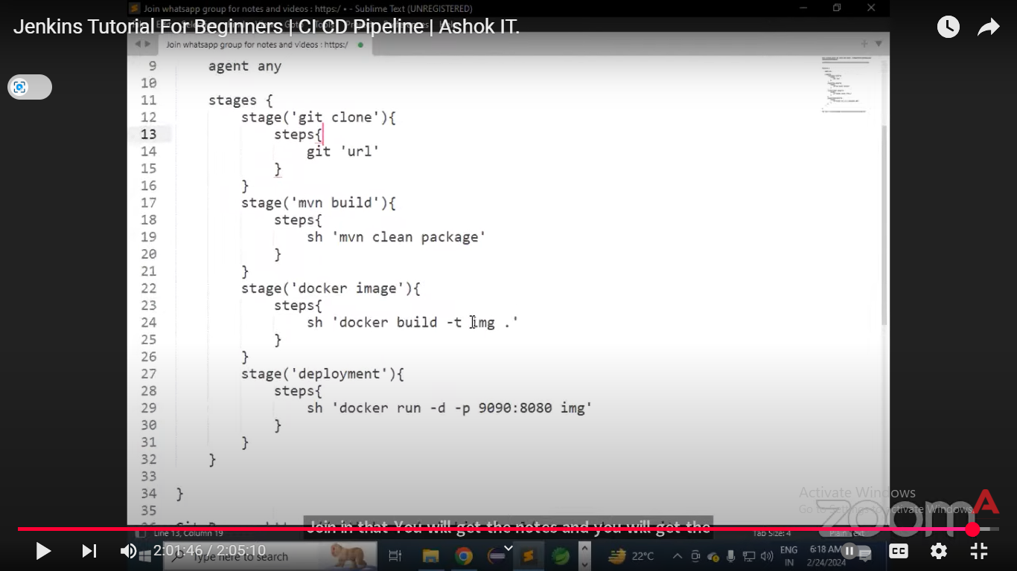

Working

pipeline {

agent any

tools {

maven 'Maven-3.8.7' // Ensure this matches Jenkins' configuration

}

stages {

stage('Clone Repository') {

steps {

git branch: 'master', url: 'https://github.com/ashokitschool/maven-web-app.git'

}

}

stage('Build with Maven') {

steps {

sh 'mvn clean package' // Runs the Maven build process

}

}

}

}

#cofnigure global tool Jenkins for maven isntallations

pipeline {

agent any

tools {

maven 'Maven-3.8.7' // Ensure this matches Jenkins' configuration

}

stages {

stage('Clone Repository') {

steps {

git branch: 'master', url: 'https://github.com/ashokitschool/maven-web-app.git'

}

}

stage('Build with Maven') {

steps {

sh 'mvn clean package' // Runs the Maven build process

}

}

stage('Building docker images'){

steps{

sh 'docker build -t my-web-app .'

}

}

stage('Deployment'){

steps{

sh 'docker run -d -p 8000:8000 my-web-app'

}

}

}

}

**#working succesffully**

pipeline {

agent any

tools {

maven 'Maven-3.8.7' // Ensure this matches Jenkins' configuration

}

stages {

stage('Clone Repository') {

steps {

git branch: 'master', url: 'https://github.com/ashokitschool/maven-web-app.git'

}

}

stage('Build with Maven') {

steps {

sh 'mvn clean package' // Runs the Maven build process

}

}

stage('Building docker images'){

steps{

sh 'docker build -t my-web-app .'

}

}

stage('Deployment'){

steps{

sh 'docker run -d -p 8000:8000 my-web-app'

}

}

}

}